|  |
| --- |
| [Invisible shadow] |
| Unsteadyland |
| **[Help the astronaut survive]** |
| Version #1.0.5  All work Copyright © 2021 by Invisible Shadow Games.  All rights reserved. |
| **[Rui Chen Geng Li - 101277255]** |
|  |

|  |
| --- |
| November 21st 2021 |

**Table of Contents**

* Version History
* Detailed Game Description
* Controls
* Interface Sketches
* Screen Description
* Game World
* Levels
* Characters / Vehicles
* Enemies (AI)
* Weapons
* Scoring
* Sound Index
* Art / Multimedia

**Version History**

Version 1.0.0 – Blank Project and GDD

Version 1.0.1 – Added Player, Enemies, Loots Sprites

Version 1.0.2 – Added Fonts and populated UIs

Version 1.0.3 – Added and implemented scene change functionalities

Version 1.0.4 – Added sound assets (SFX and background music)

(Current) Version 1.0.5 – Finalized scene layouts for draft #1

[This is the body of your video game design document. You should add and delete sections as they pertain to your game’s design.]

1. **Game Overview**

*The astronaut must survive long enough (for the duration indicated by the timer displayed on the screen), during which he/she will need to defeat monsters and collect loots to obtain ammo and score.*

1. **Game Play Mechanics**

*The player can defeat the monsters by performing close range attacks (with the sword) or by shooting them with a rifle. Each kill will award a specific amount to the score. The player will also be able to pick up random loots (to increase score), health potions (to increase live counts), and ammo chests (to replenish/add extra ammunitions). The player can be killed on contact with the enemies, as well as by falling into the abyss, and by stepping on explosive platforms (red). Solid platforms are safe for the player to stand on, and slippery platforms (blue) have a decreased coefficient of friction using a physics material that makes movement a bit tricky.*

1. **Camera**

*2D orthographic view from the camera. The start scene also uses 2 cameras, one for UI and one for the game objects. This is done so that instruction menu can clearly show the appropriate icons (health, loots, weapons, etc.) in the correct position.*

1. **Controls**

*The game uses a joystick to control the player’s movements. Pressing button A for attack, J for jump, and C for changing weapons (sword – short range, and rifle – long range).*

1. **Saving and Loading**

*Currently, since there is only one level. The only saving present is by using a public static class to pass the player’s final score and state (win/lose) to the end scene.*

1. **Interface Sketch**

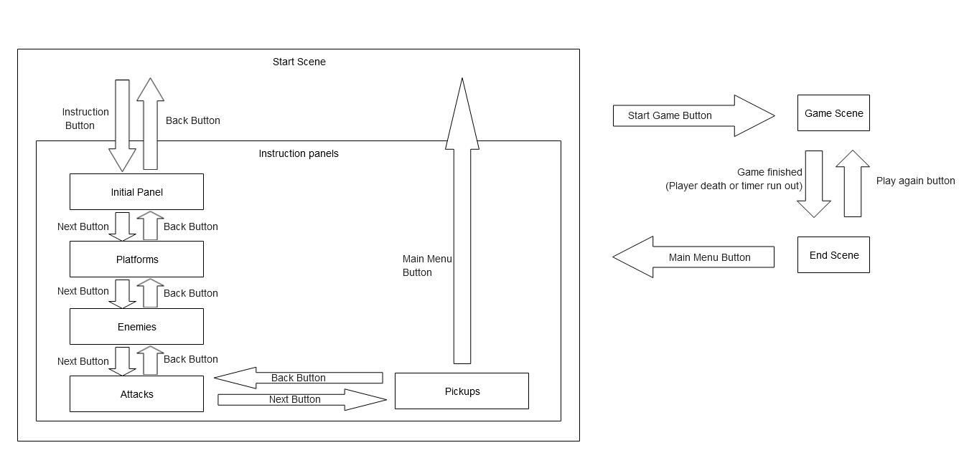

1. **Menu and Screen Descriptions**

*(Include additional screen shots and accompanying descriptions for any menus and additional screen)*

1. **Game World**

*(Describe Your Game Environment)*

1. **Levels**

*(Describe Each of your game levels)*

1. **Game Progression**
2. **Characters**

*(Describe Your game avatar if applicable)*

1. **Non-player Characters**

(Describe Any Computer controlled Allies and how they work)

1. **Enemies**

*(Describe computer-generated enemies and boss monsters)*

1. **Weapons**

*(Describe any weapons available to the user)*

1. **Items**

*(Describe any in-game items that can help or hinder the user)*

1. **Abilities**
2. **Vehicles**
3. **Script**
4. **Scoring**
5. **Puzzles/Mini-games**
6. **Bonuses**
7. **Cheat Codes**
8. **Sound Index**

*(Include an index of all your sound clips)*

1. **Story Index**

*(Outline your game story here)*

1. **Art / Multimedia Index**

*(Include an index of all your graphic and video assets here)*

1. **Design Notes**

*(Include additional design notes here)*

1. **Future Features**

*(Include any future features that are planned to be implemented)*